**Introduction/Business Problem:**

**Ravi is a businessman residing in Bangalore. He wants to find out the best possible location within Bangalore within his “Postcode” are for opening up a “Bengali Restaurant”.**

**He resides in Bangalore in a place having Postcode =”560067”.**

**Data Section:**

**Datasets which have been used in this project are as follows:**

1) I used the first table from website “**https://finkode.com/ka/bangalore.html**” for Post office Names and Pin-code of Post Offices in Bangalore City in India.

2) I**have downloaded a location data set from the website "http://www.geonames.org/export/zip/" which consists of Pin-Codes and Geospatial Co-ordinates of respective Pin-codes of India.**

**This dataset would be used to create the working “DataFrame” for the project. It consists of fields like Neighbourhood, State, District, Latitude and Longitude**

**3)**

I have used  "**Average Housing Price Rate per Squate feet,Bangalore.csv**" dataset from the website “<https://www.99acres.com/property-rates-and-price-trends-in-bangalore>”

I have used this data set to get the Housing Price rate of a particular location based on Pincode.

4) I have used Foursquare Location Data for retrieving Venue details for a particular Pincode in Bangalore.

**Methodology:**

1. I have wrangled data from the website [**https://finkode.com/ka/bangalore.html**](https://finkode.com/ka/bangalore.html)for names of Post offices and Pin codes for Bangalore (India).
2. I have downloaded a location data set from the website "http://www.geonames.org/export/zip/" which consists of Pin-Codes and Geospatial Co-ordinates of respective Pin-codes of India. This dataset would be used to create the working “DataFrame” for the project. It consists of fields like Neighbourhood, State, District, Latitude and Longitude
3. I have used Foursquare API for getting Venue details nearby Pin code “560067”
4. The foursquare API returned only 1 predominant venue i.e. “IT Services”

5)I have grouped rows by “Neighborhood” by taking the mean of the frequency of occurrence of each category so that I could apply K-Mean Clustering Algorithm later on.

6)I have used K-Means Clustering Algorithm segregating the Venues and Pin Locations

7)I have done a VLOOKUP of Average House Price Data retrieved fromthe data set from “”<https://www.99acres.com/property-rates-and-price-trends-in-bangalore>”. And I have merged this the final DataFrame.

1. Based on the Average Housing Price I have selected “Kadugodi” for opening up a Bengali restaurant, since housing Price is less as compared to the other Neighborhood.

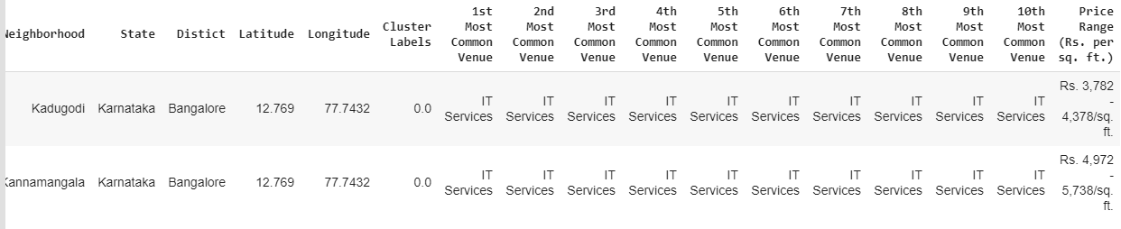

**Conclusion:**

Based on my analysis of Neighbourhoods in the vicinity of the Pin code 560067, I recommend Ravi to choose “Kadugodi” as the preferred Location for opening up a “Bengali Restaurant”